CSD 330 – Security Analytics

HW #3

Kabir Kanha Arora

Theoretical Exercises

- Can the SVM classifier we discussed in class be changed so that it outputs a probability distribution on the test data set? That is, instead of just classifying the data, can it also output a probability value that gives an idea of the confidence the SVM model has in its classification. If yes, explain how it can be done. If not, justify why it cannot be done.
Answer:
  - YES
  - This can be done by calculating the distance of the points from the separating hyperplane of the classifier.
  - During the training phase, we could divide the training samples into categories that have an equal number of samples, based on their distance from the hyper plane. Then, give a training point, the probability estimate would be calculated as the fraction of true positives. The number of bins can be chosen by cross validation.
  - OR, the distance can also be used along with a sigmoid function.

- Suggest two different ways to input a text document to a neural network for classifying it into topic categories. How many input neurons would we need for each of them? Justify your answers.
Answer:
- Binary Representation
Here, we do not need any pre-processing of text and the order and frequency of words is considered. We form a ‘vocabulary’, which could become too big for a large document. A maximum length must be set. Each word is associated with a number that is then represented in its binary form. For a document, as each word is read, its binary equivalent is concatenated to the initially empty vector representing the document. If the document is shorter than the maximum length specified, then the vector is padded with 0s.
- Bag of Words
In this, we require a set of documents to build a ‘vocabulary’. We need to discard stop words and lemmatise the remaining words to determine their importance. Tf-idf scores are calculated for each word. Once a vocabulary has been constructed, each document can be represented by a vector of the same size as the vocabulary. Each dimension of the vector would represent the presence or absence of a word in the vocabulary. In this case, the neural network would require several input nodes equal to the size of the vocabulary apart from the bias input.

- Compare Naive Bayes, k-NN and decision tree classifiers with respect to complexity of training and testing, the assumptions made, the parameters involved, objective function, optimisation technique, and expected dataset type(s).
Answer:
 | - Naïve Bayes | - Decision Trees | - k-NN
- Complexity of Training and Testing | - There is no dedicated training phase. The algorithm computes probabilities for the tests data based on the training data and assigns values accordingly. | - Out of all three, this requires the most careful training. We need to select parameters carefully to create the branches in the trees based on an impurity function. Overfitting can be reduced by pruning, which may also enhance the speed of the classifier. | - Classification is done at run time, no training required.
- Parameters Involved | - Conditional Probability, Class Probability. | - Cost function, Min. samples at leaf node, Max. depth allowed. | - k, Distance function
- Assumptions | - All the features are independent and make equal contributions. | - None. | - Similar examples exist together.
- Objective Function | - None. | - Gini impurity, Entropy or information gained, etc. may be used as the cost function. | - None.
- Optimisation Technique | - Log probabilities, if many probabilities are being multiplied.  - Calculation can be parallelised.  - No. of features can be reduced. | - Pruning done to reduce no. of nodes while not compromising on accuracy. | - No. of features used should be selected carefully. Less important features should be discarded. Collinearity must also be investigated.
- Expected dataset Type | - Performs well with small training sets. Work with all sizes and are scalable. | - Computationally intensive with large datasets. But this process needs to be done just once. Classification of new samples is quite cheap once the tree is ready. | - Performance wanes as dataset size increases, these are the least scalable. Too many calculations required in a large dataset.

- Consider a triangle in the 2-dimensional plane with one vertex at (0,0), the second at (2,0) and the third at (1,1). All points within the triangle are in class 0 and all points outside are in class 1. Design a neural network for this task. Show the connections, the activation functions, the weights, etc.
Answer:
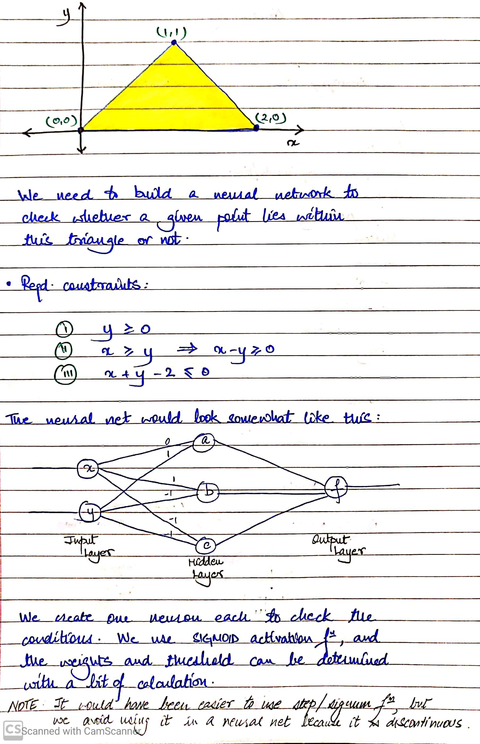
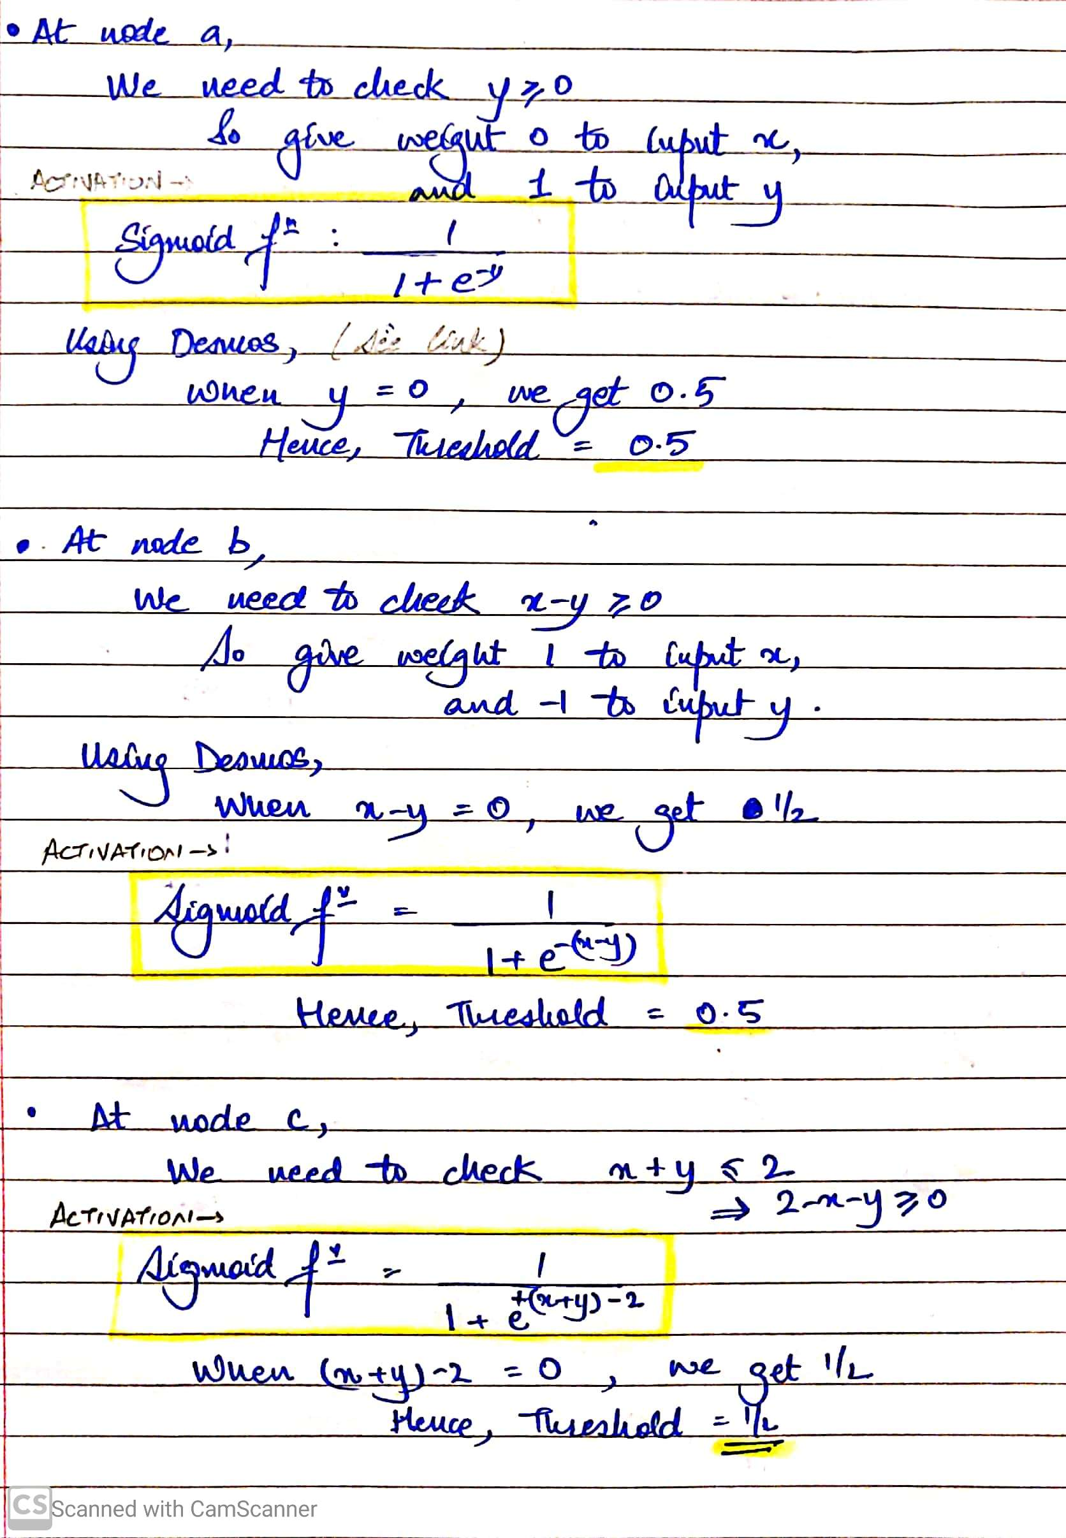
https://www.desmos.com/calculator/rhctbc4e1a

- What are the main similarities and differences between the RNN and CNN models? Which one would you use for intrusion detection and why?
Answer:
CNN | RNN
- CONVOLUTIONAL NEURAL NETWORK | - RECURRENT NEURAL NETWORK
- Good at problems like image and object classification. The building blocks of CNNs are filters a.k.a. kernels. Kernels are used to extract the relevant features from the input using the convolution operation. | - Good with contiguous series of data. RNN captures the sequential information present in the input data i.e. dependency between the words in the text while making predictions
- More suitable for spatial data | - More suitable for temporal data
- They essentially have four parts – convolution layers, ReLU layers, pooling layers and fully connected layers. | - Made up of one node.
- It usually takes a 2D matrix and outputs a result. | - It is fed data then outputs a result back into itself and continues to do this.
- Only considers current input i.e. there are only feed forward connections | - Also looks at previous input.
- CNN captures the spatial features from an image. Spatial features refer to the arrangement of pixels and the relationship between them in an image. CNN follows the concept of parameter sharing. A single filter is applied across different parts of an input to produce a feature map | - RNNs share the parameters across different time steps. This is popularly known as Parameter Sharing. This results in fewer parameters to train and decreases the computational cost.
- CNN learns the filters automatically without mentioning it explicitly. These filters help in extracting the right and relevant features from the input data | - Deep RNNs (RNNs with many time steps) also suffer from the vanishing and exploding gradient problem which is a common problem in all the different types of neural networks.
- Takes fixed size inputs and generates fixed size outputs. | - Able to handle arbitrary input and output lengths

- My suggestion is to use RNNs for intrusion detection as they have memory and can remember past behaviour which was suspicious and match patterns of some sort. They can also be used to perform both binary classification as well as multiclass classification. This would allow for not just intruder detection, but also the type of intrusion. Also, RNNS work far better than CNNs with text data, and can handle contiguous streams of data in a much better fashion. So, the choice is obvious.

- How can an attacker force a Naive Bayes classifier for spam emails that we discussed in class? Give at least two different ways.
Answer:
- If the attacker knows the design of the classifier and the words it is sensitive towards, he could simply use synonyms instead and avoid using those particular words to sidestep the classifier.
- The attacker could add deliberate typos or use SMS lingo that may not be picked up by the classifier.
- The attacker may add special symbols or join words using white coloured characters, which makes the email appear normal to the end user and avoid recognition as spam.

- Using the method of Lagrange multipliers, minimize x2+y subject to the constraint x2+y2=9, show all your steps.
Answer:
